THE RENAISSANCE AUCTION GROUP
REAL ESTATE AUCTION

WEDNESDAY FEBRUARY 10TH 5 pm
1154 GREEN ST READING, PA 19604
SELLING ABSOLUTE TO THE HIGEST BIDDER REGARDLESS OF PRICE

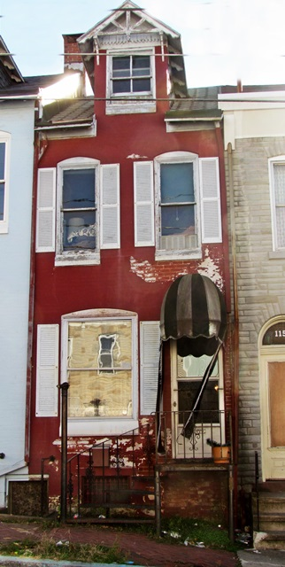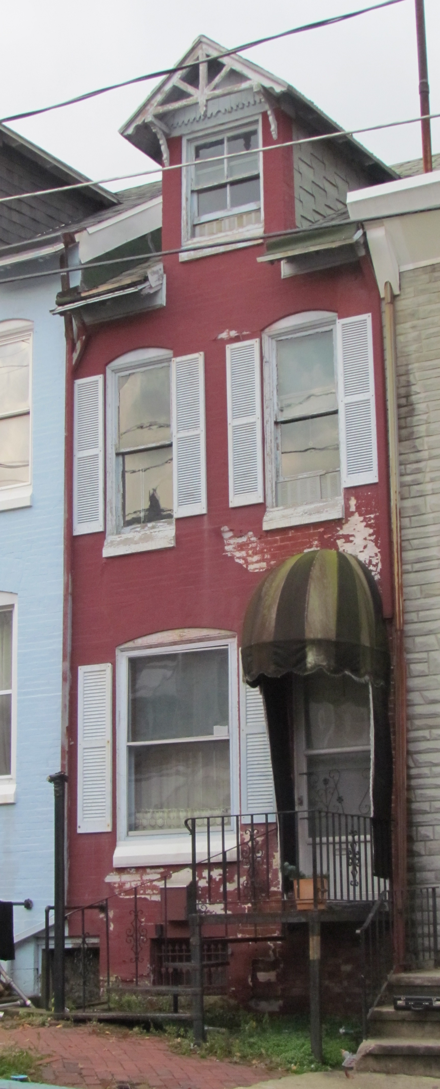

ON SITE ESTATE SALE: SATURDAY JANUARY 30TH 9AM-2PM
REAL ESTATE PROPERTY INSPCTIONS: SAT. 1/30 & SUN 2/7 NOON – 2 PM

Two BR, One Bath Townhouse w/ Master Bedroom Suite, Living Room, Kitchen, Dining Room, Third Floor Atelier, Hardwood Floors; Close To Schools, Transportation Arteries and Shopping. Excellent Opportunity To Purchase Affordable Housing, Rental Or Resale Property.

ALL MEASUREMENTS APPROXIMATE
- INTERIOR SQ FOOTAGE: Finished - 1120 Sq Ft; Total – 1550 Sq Ft

First Floor
Living Room – 25’10” x 10’11” 291Sq. Ft.
Kitchen – 13’7” x 6’10” 94 Sq Ft
Dining Room – 13’5” x 7’ 100 Sq Ft
Second Floor
Master Bedroom 27’7” x 7’1” 200 Sq Ft
North Bedroom 12’9” x 10’7” 136 Sq Ft
Bath - 9’ x 5’ 45 Sq Ft
Third Floor
Attic Bedroom – 18’7” x 11’ 200 Sq. Ft

II. PLUMBING
A. Municipal Water & Sewer
B. Copper, PVC & Cast Iron
C. 40 Gal Electric Hot Water Heater

www.auctionhowze.com 610-370-2879 bill@auctionhowze.com

III. ELECTRICAL
- 100 Amp Box w/ Breakers

IV. HEATING / COOLING
- Oil Fired Forced Air
- 250 Gal Oil Tank Approximately 1/2 to 2/3 Full

V. ROOF
A. Asphalt Shingles
B. Rolled Roofing (Kitchen, Utility Room. Workshop)

VI. TAX INFORMATION
- 2015 Annual Tax Total $1129 (School $486; County $206; Municipal $438
- 2015 Tax Assessed Value - $$27900

VII. LOT INFORMATION
- 5923 Sq Ft

VIII. NOTES
A. Fenced Back Yard
B. Contemporary Hardwood Floors
C. Vintage Oak Staircase
D. Knotty Pine Walls In Master Bedroom
E. Distressed Wood Plank Walls In Living Room
F. Oak Cabinets In Kitchen
G. Third Floor Attic Bedroom
H. Neighborhood Rent Average For Similar Properties $600

IX. TERMS OF AUCTION
REAL ESTATE: $3,000 Down Day Of Auction. 10% Buyer's Premium. Thirty Days to Close.

HOW TO PARTICIPATE IN THE REAL ESTATE AUCTION

1) Inspect The Property By Attending An Open House Or Schedule A Property Inspection Appointment

2) Obtain A Property Information Pack & The Terms & Conditions Of Sale In Person Or By
Downloading The Documents From Our Website: www.auctionhowze.com

3) Bring Cash Or A Cashier's Check To The Auction In The Amount Of $3,000.00. Have The Cashier's
Check Made Out To You. If You Are The Successful High Bidder, You Will Endorse The Check
And Make It Payable To The Escrow Agent.

4) Bid Your Price. You Could Be The New Owner Of This Desirable Property At A Price You Determine

5) If You Have Any Questions Or Need Further Assistance Please Refer to The Contact Information Below

CONTACT INFORMATION:
E-Mail - bill@auctionhowze.com
Phone - 610-370-2879

We Make A Difference You Can Take To The Bank

